**Christopher King**

**2018141521058**

**Applied Fluid Mechanics**

**Class Section 01**

**05/25/2021**

# **Problem 12.9**

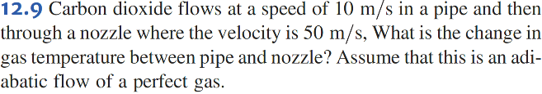

**Solution:**

Assume a constant specific heat

# **Problem 12.21**



**Solution:**

Take average:

# **Problem 12.25**

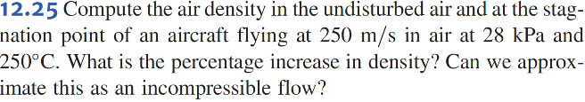

**Solution:**

Therefore, we cannot approximate this as an incompressible flow.